**Amarilda Celhaka**

**CS 4250 Programming Languages Spring 2019**

**----------------------------------------------------------------------------------------------------**

**Assignment #3**

Using SWISH (SWI Prolog for Sharing). Running each of your programs by typing a query and clicking on ‘Run’ button.

1. Consider a hypothetical family tree shown below:

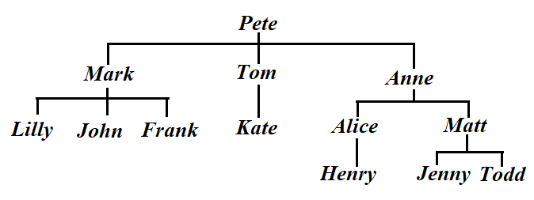

Create a simple database containing facts and inference rules. Include facts about family members, such as *male*, *female*, *parent*. Then add rules such as *sister*, *brother*, *sibling*, *father*, *mother*, *grandparent*.

Run queries that will answer the following questions about family members:

(a) Is Pete Mark’s parent?

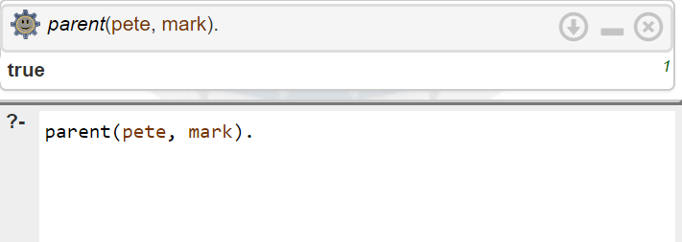

(b) Is Anne Jenny’s parent?

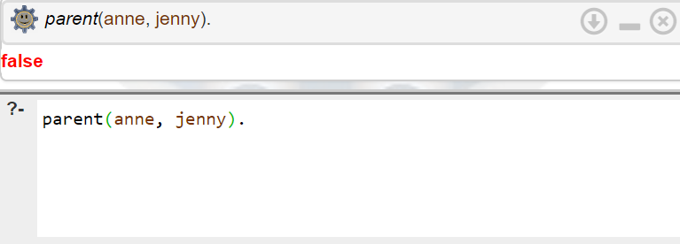

(c) Who is Todd’s father?

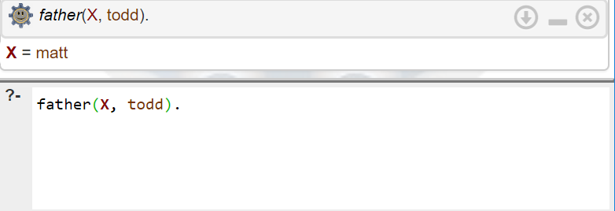

(d) Who is Tom’s sibling?

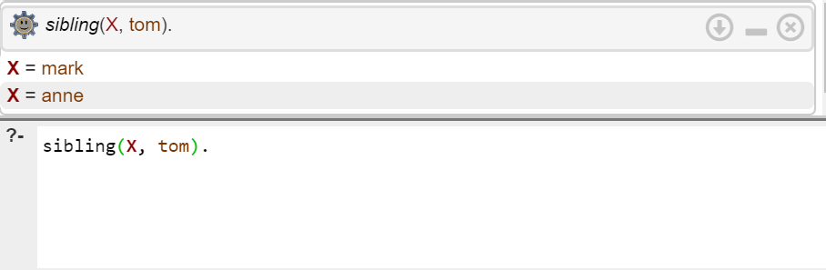

(e) Who is Lilly’s brother?

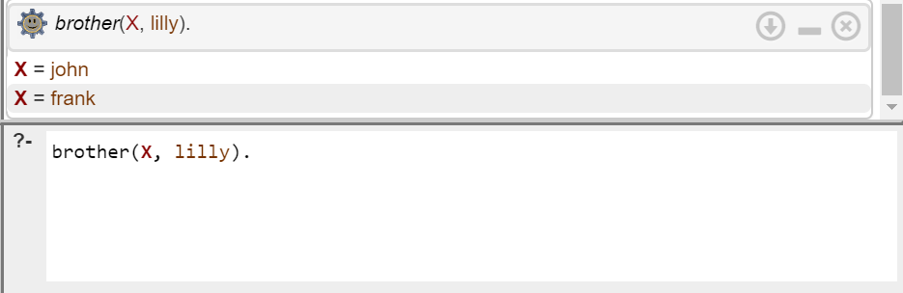

(f) Who is Henry’s grandparent?

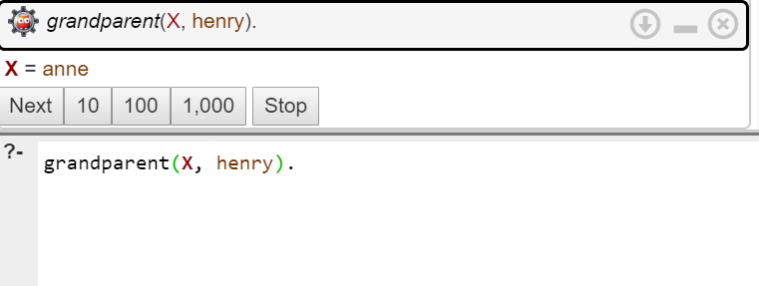

(g) Who is Alice’s sister?

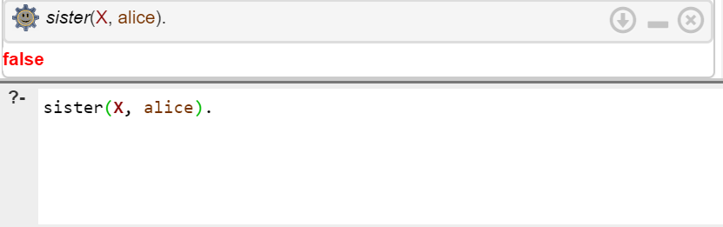

(h) Is Frank Kate’s brother?

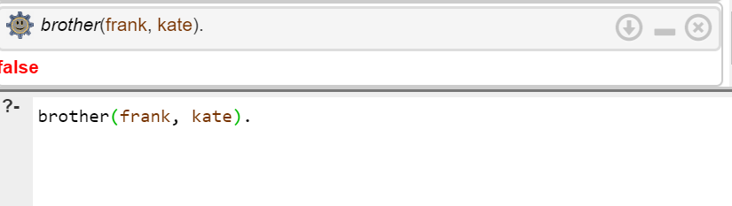

(i) Who is Matt’s mother?

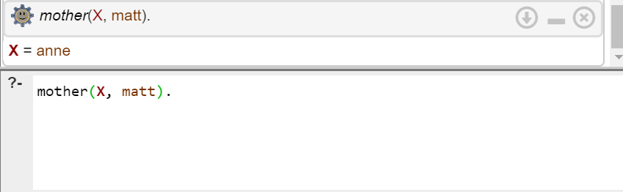

(j) Is Mark Anne’s brother?

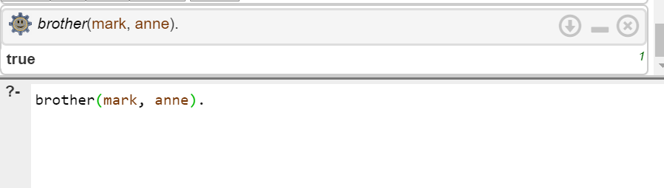

(k) Who are Pete’s grandchildren?

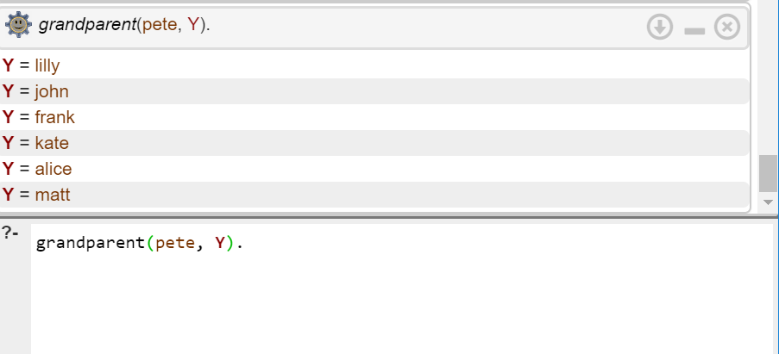

(l) Who are Mark’s children?

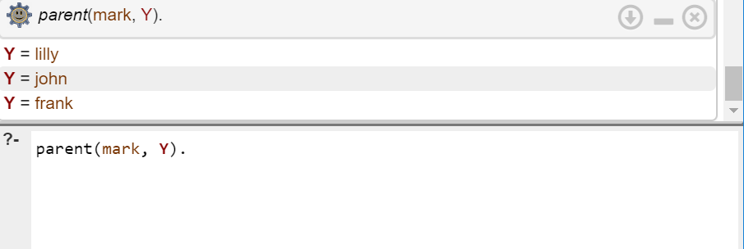

1. Write a Prolog program that finds the maximum of a list of numbers. Submission file should include a screenshot with tracing a program execution when a list only has 2 members and execution without tracing when a list has 8 elements.

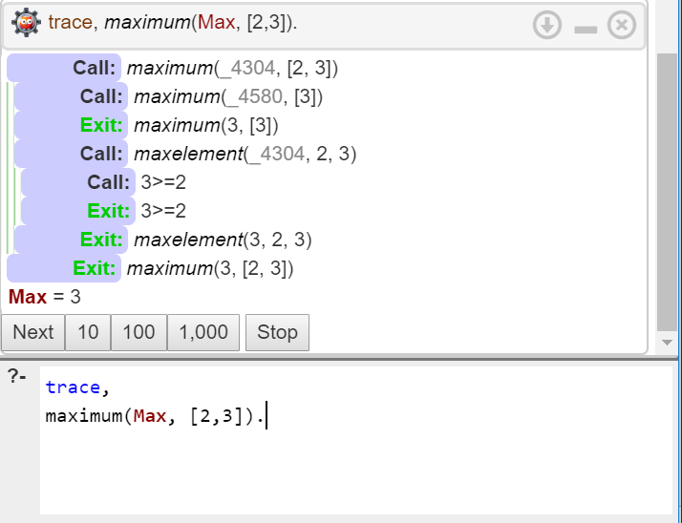

List with 8 elements:

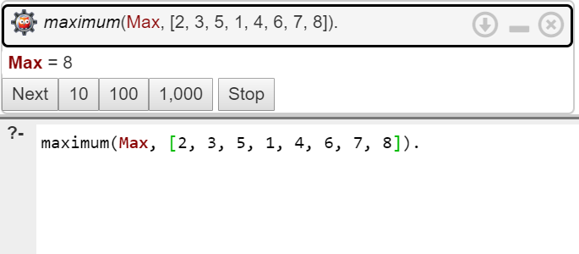

1. Write a Prolog program that returns a list containing a union of the elements of two given sets.

